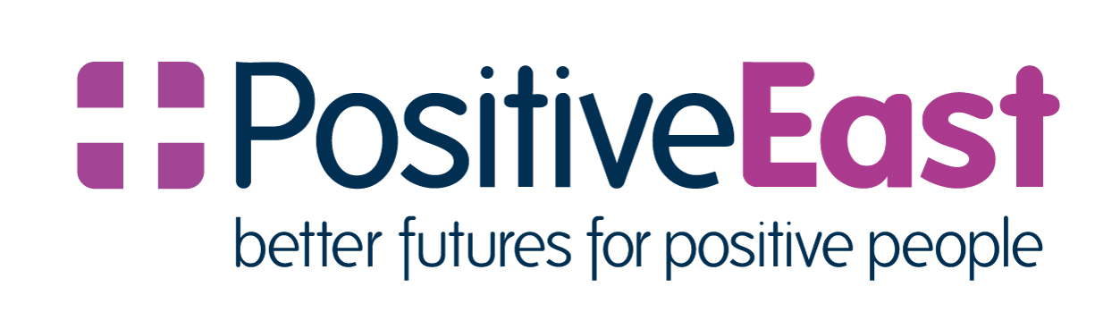

Positive East is an East London charity that provides support and advice services to people living with HIV. They have been at the forefront of HIV service and care for over 30 years; supporting people from point of HIV diagnosis to longer term care. While there have been some fantastic developments in HIV medication and medical care, there are still huge barriers that many people living with HIV face. These can include social isolation, poor mental health and a lack of self-worth as well as issues such as financial hardship and lack of access to stable housing.

Every year, Positive East supports more than 4,000 people with services such as counselling sessions, support groups, their advice line and their health and wellbeing programme as well as providing free HIV/STI tests to the local community.

Their vision is “A world where people living with HIV are able to fulfil their potential, free from stigma and discrimination, living full healthy lives” and their mission is to “Improve the quality of life of individuals and communities affected by HIV”.

East London, and Hackney in particular, has a much higher rate of HIV diagnoses than the national average yet the HIV and sexual health sector is experiencing severe funding cuts every single year. Positive East is now relying more than ever on the generosity of the local community to support their vital work.